The Fairfield Area School District’s 2024-2025 Equity Plan
Revised: April 2023

- An Equity Worksheet providing school data on the following:
  - School Poverty Percentage
  - School Minority Percentage
  - Teachers’ Highly Qualified Status
  - Teacher Experience Percentage

- A general summary of findings that show where possible inequities exist.

- A data report on core academic subject teaching vacancies that are difficult to fill with highly qualified teachers, by school and grade level.

- A description of strategies the District is implementing to ensure that poor and minority students are not taught at higher rates than other students by inexperienced, unqualified and/or out of field teachers.

- Procedures to Determine the Effectiveness of Strategies. Pennsylvania’s Definition of Highly Qualified Teacher

To satisfy the definition of a Highly Qualified Teacher, teachers must:
- 1) Hold at least a bachelor’s degree;
- 2) Hold a valid Pennsylvania teaching certificate (i.e., Instructional I, Instructional II or Intern certificate but not an emergency permit); and
- 3) Demonstrate subject matter competency for the core content area they teach.

Core content areas include English, Reading/Language Arts, Mathematics, Sciences, Foreign Languages, Music and Art, and Social Studies (history, economics, geography, and civics and government).
Districts may apply to the Pennsylvania Department of Education for Emergency Permits in these areas if a highly qualified teacher cannot be employed to fill the vacancy. The highly qualified teacher requirements also include:
o Elementary level (grades K-6) teachers who teach all subjects to a particular grade;
o Middle and secondary-level (grades 7-12) core content area instructors;
o Special education teachers who provide direct instruction in one or more core content areas; English as a second language (ESL) teachers who provide direct instruction in one or more core content areas; and
o Alternative education teachers who provide direct instruction in one or more core content areas.

For teachers in the above areas, High Objective Uniform State Standard of Evaluation, or HOUSSE Programs (Bridge, Bridge Extension and HOUSSE) were available until June 30, 2007.

Tables 1 and 2 represent data relative to building demographics. These demographics include the percentages of poverty and minority students in Fairfield Area Elementary School. Also presented are the percentages of highly qualified teachers and experienced teachers in Fairfield Area Elementary School. Table 3 provides data on the core academic subjects and grades not currently filled with a highly qualified teacher. This information includes the area of special education.

Table 1: Fairfield Area Elementary School Demographics
School | % of poverty | % of Minority | % of HQ teachers | % of non-tenured teachers
Fairfield Area Elementary School | 34.2% | 4.8% | 100% | 27%

Table 2: Fairfield Area Elementary School
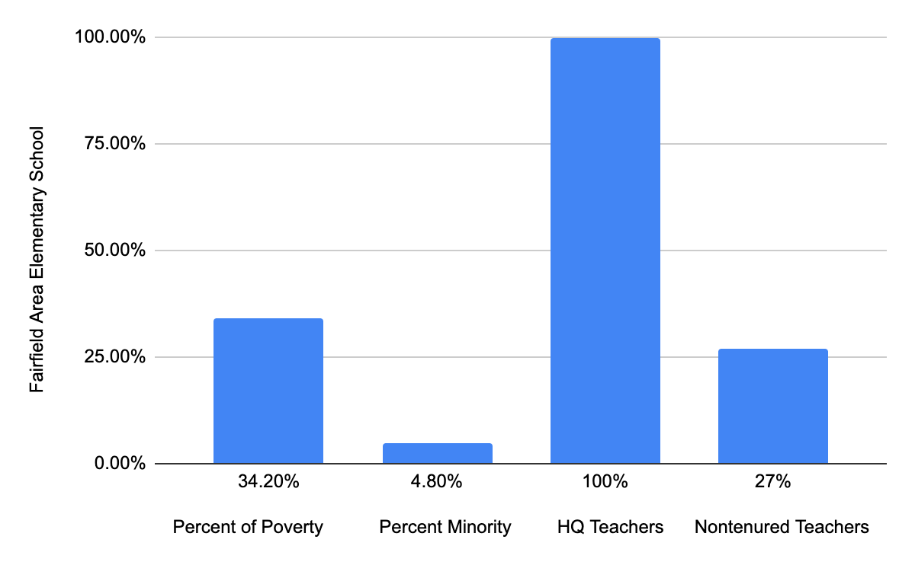

Table 3: Core Academic Subjects and Grades Not Currently Filled By Highly Qualified Teachers. (2022-2023)
School | Subject | Grade(s) | # of vacancies filled by non- HQT
Fairfield Area Elementary School | N/A | N/A | N/A

All teachers are currently meeting the criteria for HQT status in the Fairfield Area Elementary School.

Summary of Findings
All Fairfield Area Elementary School professionals are currently highly qualified.

Strategies
The District is currently, or will be, implementing the following strategies to ensure that poor and minority students are not taught at higher rates than other students by inexperienced, unqualified and/or out of field teachers.
Current strategies
- Advertising Vacancies
a. Advertise via District Website, hiring websites, and social media.
b. Enhance communication with employees to identify and advertise potential vacancies as early as possible.
- Professional Development
a. Offer training and workshops to strengthen content knowledge and
instructional strategies.
- Student Placement
  - All students have an equal opportunity of placement in elementary classrooms.

Future Strategies
- Advertising
a. Explore broadening our reach
b. Explore additional recruiting opportunities
- Work with local colleges and universities to have opportunities for our Principals
and Administrators to visit local universities and colleges to discuss the benefits
of working in the Fairfield Area School District.
- Maintain an ongoing file of prospective teachers and educational
specialists.
- Evaluate and interview student teachers as perspective future employees.Performance standards for Pennsylvania student teachers mirror the performance standards for Fairfield Area School District teachers.
- Initiate the hiring process as soon as we are aware of a vacancy or opening. By maintaining records of potential employees, we are in a position to interview early and offer jobs in a very timely manner.
- Continue working to align our system of recruitment, hiring, induction, supervision, and professional development.

Measuring Success
Success will be measured by continuing to fill and retain highly qualified professionals.

PUBLIC LAW 107-110-JAN.8, 2002
“SEC. 1112. LOCAL EDUCATIONAL AGENCY PLANS.
“© ASSURANCES. –
“(1) IN GENERAL. – Each local educational agency plan shall provide assurances that the local education agency will –
“(L) ensure, through incentives for voluntary transfers, the provision of professional development, recruitment programs, or other effective strategies, that low-income students and minority students are not taught at higher rates than other students by unqualified, out-of-field, or inexperienced teachers;

